Week 3 Homework assignment

- Which month and year did the most profit?
Answer:
The line graph in the top left corner of the dashboard shows the monthly profit trend. The peak appears around December 01, 2014, indicating that it had the most profit.
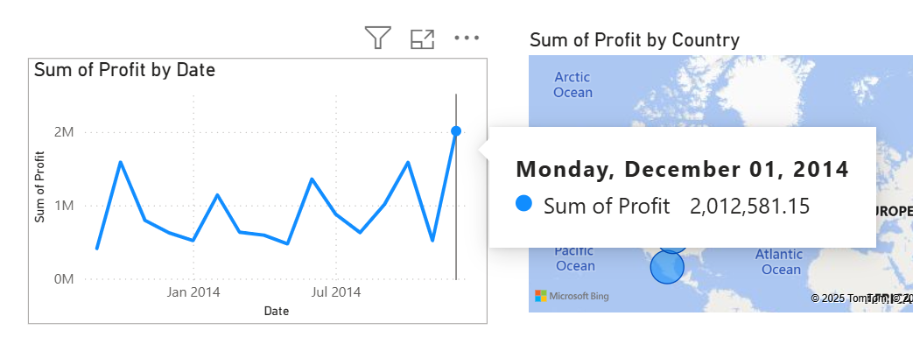

- Where is the company most successful (by country/region)?
According to the map visualization on the top right of the dashboard, the highest concentration and size of data points are in France, suggesting it is the most successful region.
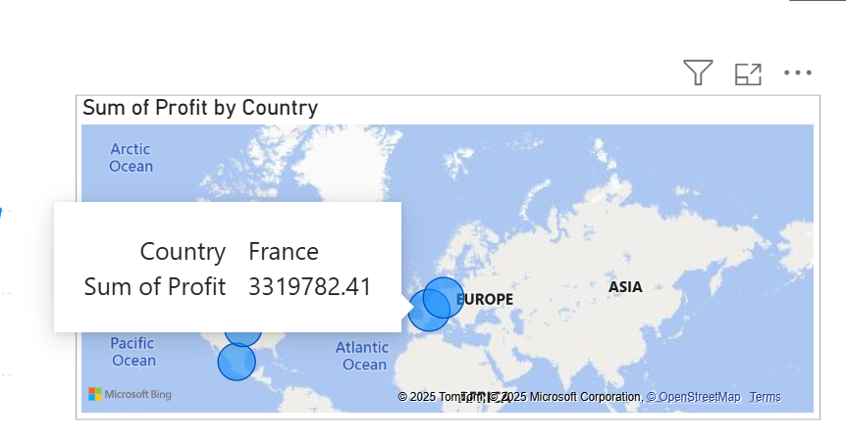

- Which product and segment should the company continue to invest in?
The bar chart at the bottom of the dashboard shows product performance by segment. Government in the Corporate segment has the highest sales, so the company should continue investing in Technology (Paseo) for the Corporate segment.
